- Checkout, the dialog will be held 5~6 mins.
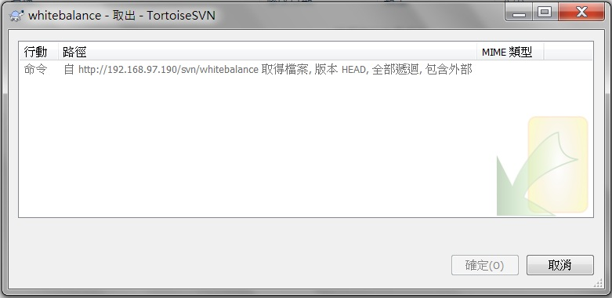
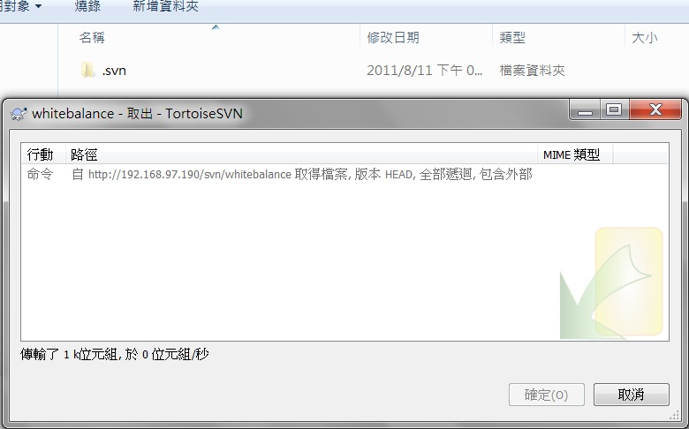
2. Then the ".svn" be created. But hold 5~6 mins again.

3. Then the checkout finish normally.
