Tortoise SVN Bug Report.
What I did:
I right clicked on the file I wanted to Commit, and clicked on SVN Commit.
Immediately message flashes up: “TortoiseSVN has stopped working”
Then the following IE screen:
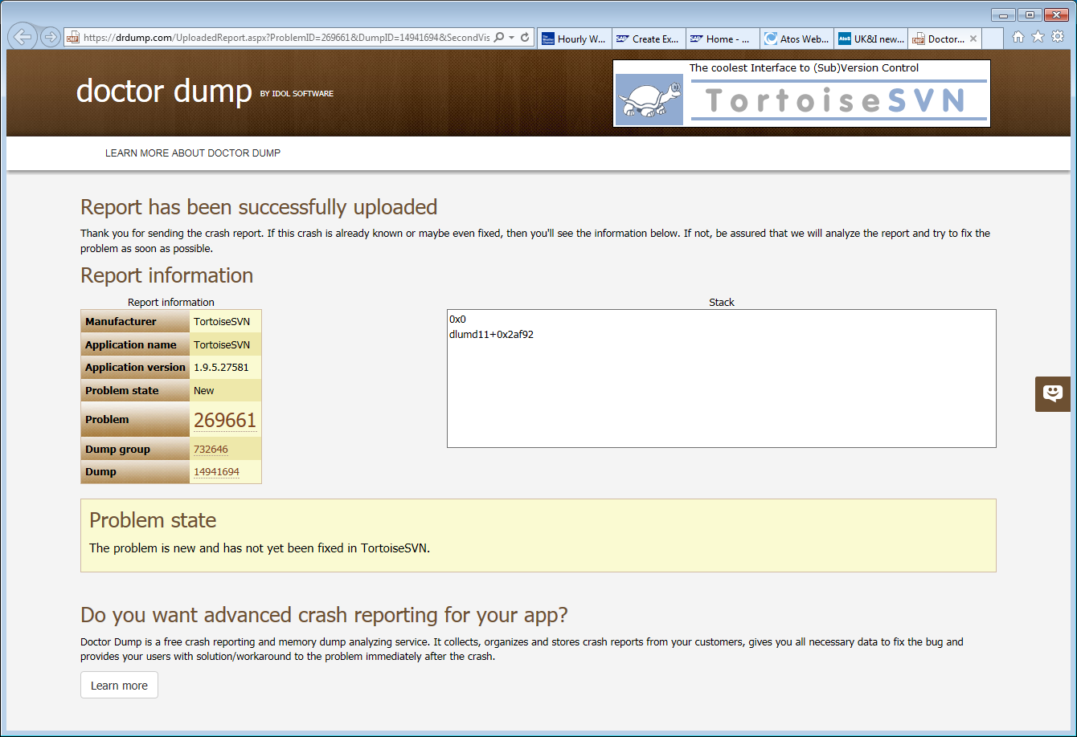
SVN Update works fine.
Relatively newly installed Laptop.
Have run the SVN Repair facility from the Tortoise Downloads site.
And Deleted the programme through Windows and re-installed.
Please help.

