Try to add keywords properties into repository
Step1. Launch repo-browser.
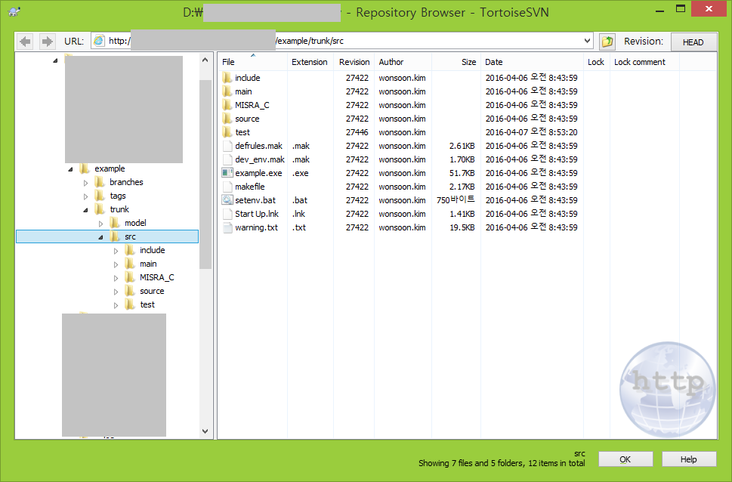

Step2. Click right mouse button to use “Show Properties”, and select “Show Properties” then the following pop-up window is opened
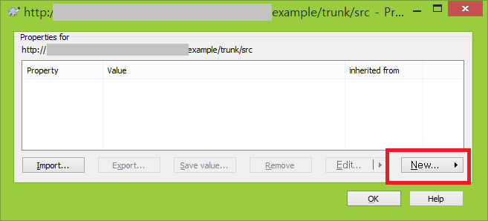

Step3. Click “New” marked with Red-Box, and select “keywords”. After launching “keywords” windows, select some keywords, and Click “OK”
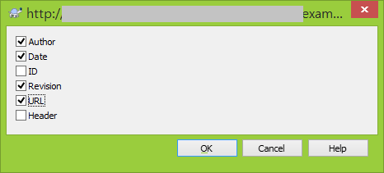

Step4. then the following Log Message Window is opened.
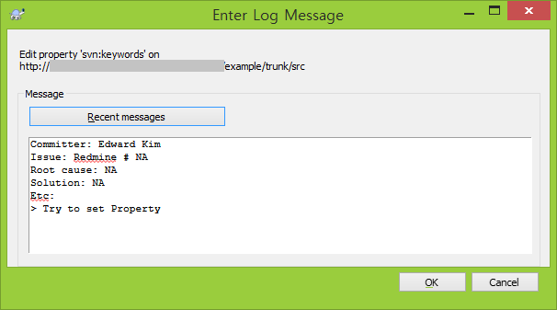
Write some notes and click “OK”

Step5. Then, the following Error Window is opened.
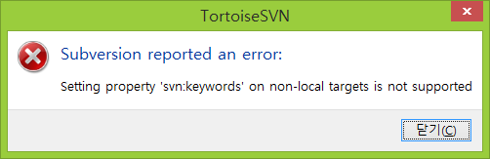
OK !! Now, I can understand that it’s not possible to configure the keywords feature into server-side setting.

Step6. I Tried to set keywords according to the previous steps on client-side as described above.
(Launch the pop-up menu with a mouse right button on the checked-out repository, and select “Properties”, just like repeating Step 2 ~ Step 5)

I cannot check “Apply property recursively” in Keywords window as shown below
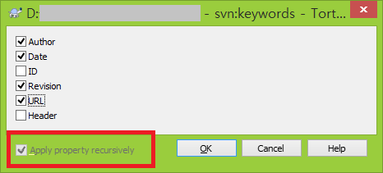
And After clicking “OK”, I cannot see any change in “Property Window”.
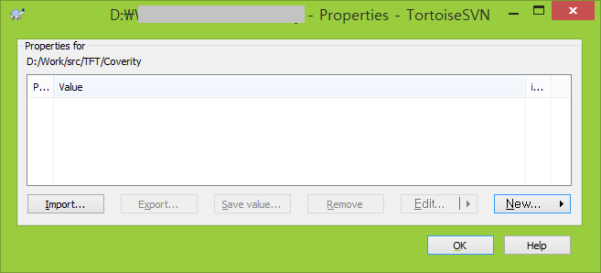
However, after committing some changed sources, then I can see “keywords” property works as shown below.
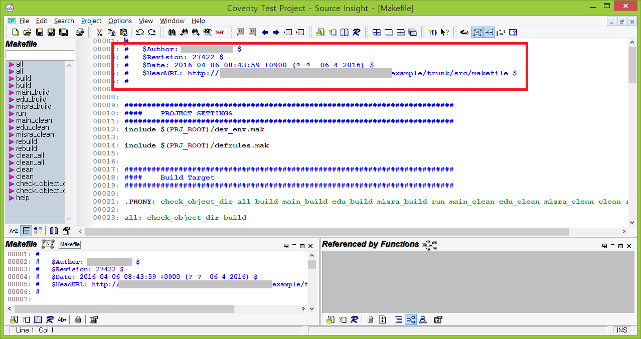

Now, my colleagues can change and commit the source, and see the changes with proper keywords properties.

My question is..
Other people (my colleagues) DID NOT do anything at their computer, but they can use these keywords properties.. Is there any metadata update in server-side ?
Is there any probability that this setting may be gone because of deleting something by mistake ?
How can I guarantee they (my colleagues) can use these without any ignorance ?

